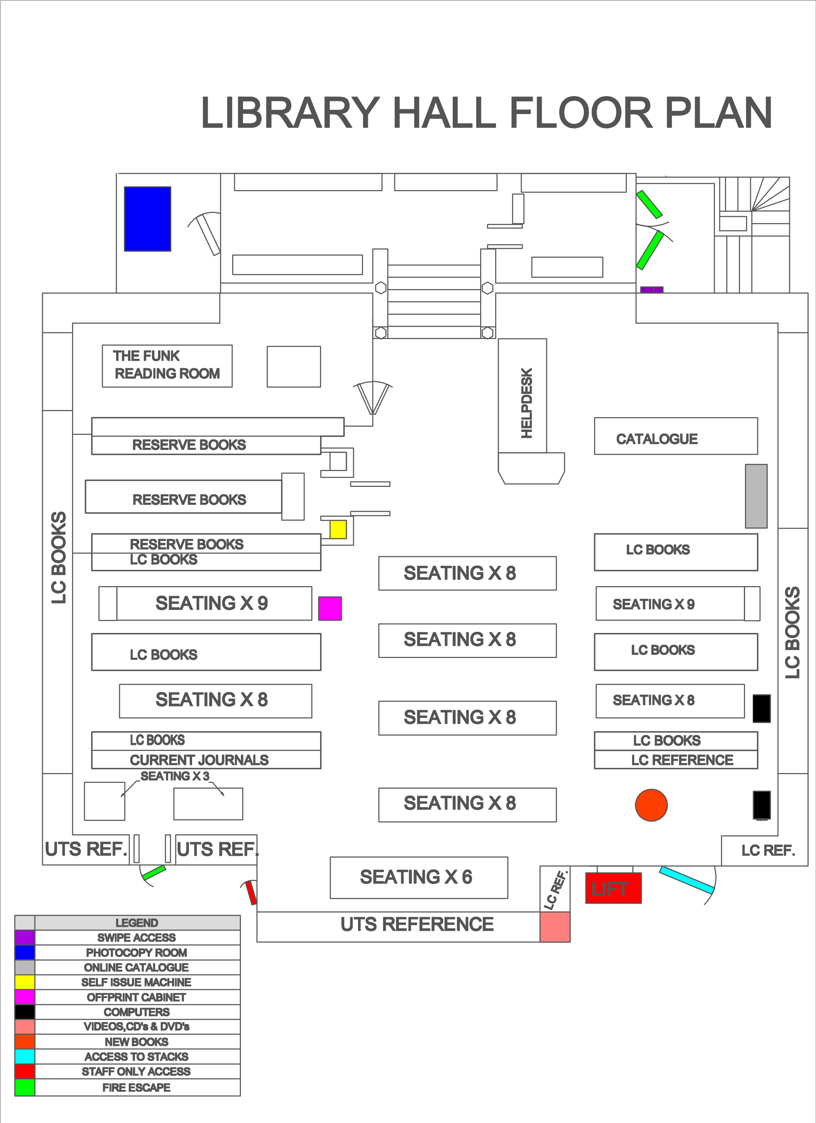

LC books (Standard Loan) A-BQ Library Hall, BR-Z continues in Stack 1

**PHOTOCOPY PRINTING ROOM**

**PHOTOCOPYPRINTING RM**

**REQUESTED ITEMS FOR COLLECTION**

**BM-BQ**

**AC - B**

**B**

**BL-BM**

**BJ-BL**

**BC-BJ**

**B**



 **LC REF.**

REF.

**LC REF.**

**LC REF.**

**LC REFERENCE**